REG NO: 22TD0053 NAME: MOHAMED B SIRAJUDDEEN
YEAR/SEM/SEC: Y3/S6/B

CREATION OF HTML FILES
SOURCE CODE
HOME PAGE:
<html>
<head>
<meta http-equiv="Content-Type" content="text/html; charset=iso-8859-1" />
<link href="style.css" rel="stylesheet" type="text/css" />
<title>Pizza huts template</title>
</head>
<body>
<div id="container">
<div id="header">
<div id="logo_w1"></div>
<div id="logo_w2"></div>
<div id="header_text">
<a href="#"></a>
</div> <ul>
<li><a href="index.html">Home</a></li>
<li><a href="Aboutus.html">About Us</a></li>
<li> <a href="Menu.html">Menu Card</a></li>
<li><a href="Contact.html">Contact us</a></li>
</ul> </div>
<div id="content">
<div id="left">
<h1>Welcome to our Bill's pizza</h1>
<p>Pizza Hut is one of the flagship brands of Yum! Brands, Inc., which also has KFC, Taco Bell, A&W and Long John Silver’s under its umbrella. Pizza Hut is the world’s largest pizza chain with over 12,500 restaurants across 91 countries.</p><p>In India, Pizza Hut has 140 restaurants across 34 cities, including Delhi, Mumbai, Bangalore, Chennai, Kolkata,
Hyderabad, Pune, and Chandigarh amongst others. Yum! is in the process of opening
Pizza Hut restaurants at many more locations to service a larger customer base across the country.</p>
<h1>Photos</h1>
<div id="photos">
<a href="#"><img src="images/photo1.jpg" alt="photo" /></a>
<a href="#"><img src="images/photo2.jpg" alt="photo" /></a>
<a href="#"><img src="images/photo3.jpg" alt="photo" /></a>
<a href="#"><img src="images/photo4.jpg" alt="photo" /></a>
</div> </div>
<div id="right">
<h2>QUOTES</h2>
<a href="#">Jim Davis</a>
<p>Vegetables are a must on a diet. I suggest carrot cake, zucchini bread,
and pumpkin pie. </p>
<a href="#">Adelle Davis </a>
<p>Eat breakfast like a king, lunch like a prince, and dinner like a
pauper.</p>
<a href="#">Elizabeth Berry</a>
<p>Shipping is a terrible thing to do to vegetables. They probably get jetlagged, just like people.</p>
</div> <div id="footerline"> </div> </div>
<div id="footer">THANKS FOR VISIT OUR WEBSITE KEEP VISITING....
Copyright © 2011 BILL'S PIZZA.All rights reserved.</div>
</div>
</body>
</html>

OUTPUT

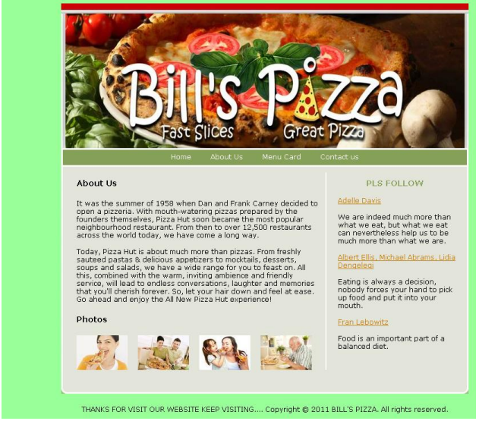

ABOUT US:
<html>
<head>
<link href="style.css" rel="stylesheet" type="text/css" />
<title>Pizza hut template</title>
</head>
<body>
<div id="container">
<div id="header">
<div id="logo_w1"></div>
<div id="logo_w2"></div>
<div id="header_text">
<a href="#"></a>
</div>
<ul>
<li><a href="index.html">Home</a></li>
<li><a href="Aboutus.html">About Us</a></li>
<li> <a href="Menu.html">Menu Card</a></li>
<li><a href="Contact.html">Contact us</a></li>
</ul>
</div>
<div id="content">
<div id="left">
<h1>Contact Details</h1>
<p>BILL'S PIZZA<br />
Houghton Street<br />
City of France, Greater France, <br />
020 7995 7686<br />
</p>
<h1>Photos</h1>
<div id="photos">
<a href="#"><img src="images/photo1.jpg" alt="photo" /></a>
<a href="#"><img src="images/photo2.jpg" alt="photo" /></a>
<a href="#"><img src="images/photo3.jpg" alt="photo" /></a>
<a href="#"><img src="images/photo4.jpg" alt="photo" /></a>
</div>
</div>
<div id="right">
<h2>Quotes of the day</h2>
<a href="#">Robert Orben</a>
<p>I take my children everywhere, but they always find their way back home.</p>
<a href="#">John F. Kennedy</a>
<p>Forgive your enemies, but never forget their names.</p>
<a href="#">George Bernard Shaw</a>
<p>Hell is full of musical amateurs.</p>
</div>
<div id="footerline"></div>
</div>
<div id="footer">THANKS FOR VISIT OUR WEBSITE KEEP VISITING....
Copyright © 2011 BILL'S PIZZA.All rights reserved.</div>
</div>
</body>
</html>

OUTPUT
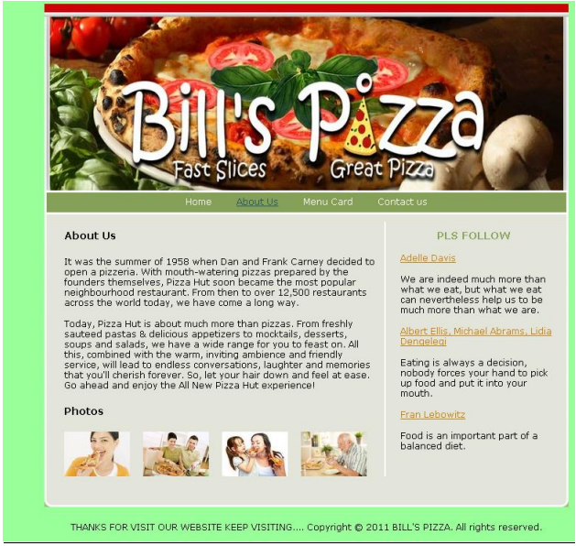

MENU CARD:
<html>
<head>
<meta http-equiv="Content-Type" content="text/html; charset=iso-8859-1" />
<link href="style.css" rel="stylesheet" type="text/css" />
<title>Make a donation</title>
</head>
<body>
<div id="container">
<div id="header">
<div id="logo_w1"></div>
<div id="logo_w2"></div>
<div id="header_text">
<a href="#"></a>
</div>
<ul>
<li><a href="index.html">Home</a></li>
<li><a href="AboutUs.html">About US</a></li>
<li> <a href="Menu.html">Menu Card</a></li>
<li><a href="Contact.html">Contact us</a></li>
</ul>
</div>
<div id="content">
<div id="left">
<h1> OUR PRICES</h1>
<table border=0 cellspacing="20" cellpadding="20">
<tr>
<th>ITEMS</th>
<th>PRICE</th>
</tr>
<tr>
<td>Hot n Spicypanner</td>
<td> Rs.500</td>
</tr>
<tr>
<td>Chiken Skewers</td>
<td>Rs.400</td>
</tr>
<tr>
<td>Chiken Sings</td>
<td>Rs.450</td></tr>
<tr>
<td>Tuscani Singles</td>
<td>Rs.300</td></tr>
<tr>
<td>Costco</td>
<td>Rs.200</td>
</tr>
</table>
<h1>Photos</h1>
<div id="photos">
<a href="#"><img src="images/photo1.jpg" alt="photo" /></a>
<a href="#"><img src="images/photo2.jpg" alt="photo" /></a>
<a href="#"><img src="images/photo3.jpg" alt="photo" /></a>
<a href="#"><img src="images/photo4.jpg" alt="photo" /></a>
</div>
</div>
<div id="right">
<h2>Motivation</h2>
<a href="#">Edward Gibbon</a>
<p>We improve ourselves by victories over ourself. There must be
contests, and you must win. </p>
<a href="#">Oprah Winfrey </a>
<p>I define joy as a sustained sense of well-being and internal peace - a
connection to what matters.</p>
<a href="#">Jef Mallett, </a>
<p>Mach-S, the speed at which stress can't keep up, is simply forward motion. But it has to be self- propelled. Note that people in cars are still stressed.</p>
</div>
<div id="footerline"></div>
</div>
<div id="footer">THANKS FOR VISIT OUR WEBSITE KEEP VISITING....
Copyright © 2011 BILL'S PIZZA. All rights reserved.</div>
</div>
</body>
</html>

OUTPUT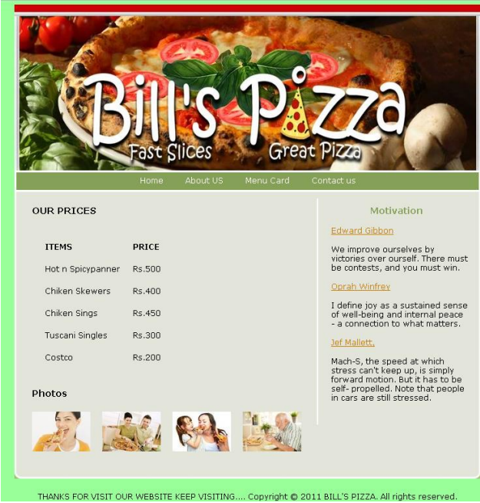

CONTACT US:
<html>
<head>
<link href="style.css" rel="stylesheet" type="text/css" />
<title>Pizza hut template</title>
</head>
<body>
<div id="container">
<div id="header">
<div id="logo_w1"></div>
<div id="logo_w2"></div>
<div id="header_text">
<a href="#"></a>
</div>
<ul>
<li><a href="index.html">Home</a></li>
<li><a href="Aboutus.html">About Us</a></li>
<li> <a href="Menu.html">Menu Card</a></li>
<li><a href="Contact.html">Contact us</a></li>
</ul>
</div>
<div id="content">
<div id="left">
<h1>Contact Details</h1>
<p>BILL'S PIZZA<br />
Houghton Street<br />
City of France, Greater France, <br />
020 7995 7686<br />
</p>
<h1>Photos</h1>
<div id="photos">
<a href="#"><img src="images/photo1.jpg" alt="photo" /></a>
<a href="#"><img src="images/photo2.jpg" alt="photo" /></a>
<a href="#"><img src="images/photo3.jpg" alt="photo" /></a>
<a href="#"><img src="images/photo4.jpg" alt="photo" /></a>
</div>
</div>
<div id="right">
<h2>Quotes of the day</h2>
<a href="#">Robert Orben</a>
<p>I take my children everywhere, but they always find their way back home.</p>
<a href="#">John F. Kennedy</a>
<p>Forgive your enemies, but never forget their names.</p>
<a href="#">George Bernard Shaw</a>
<p>Hell is full of musical amateurs.</p>
</div>
<div id="footerline"></div>
</div>
<div id="footer">THANKS FOR VISIT OUR WEBSITE KEEP VISITING....
Copyright © 2011 BILL'S PIZZA.All rights reserved.</div>
</div>
</body>
</html>

OUTPUT
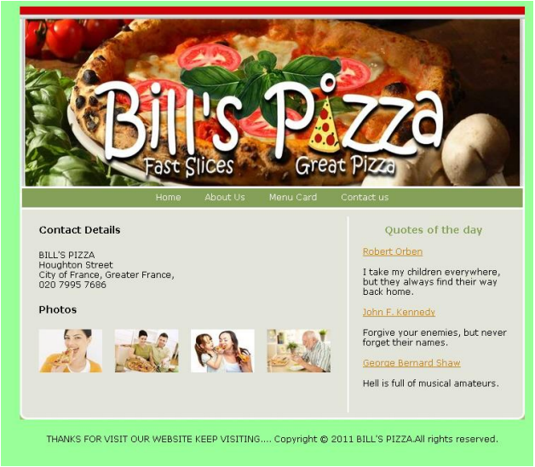
CASCADING STYLE SHEET:
body {
background-color:#99ff99;
color:#000000;
font-family: Verdana, Arial, Helvetica, sans-serif;
font-size: 12px;
margin: 10px 10px;
padding: 0px;
}
.clear{clear:both;}
* {
margin: 0px;
padding: 0px;
}
#container {
margin: 0px auto;
text-align: left;
width: 717px;
}
a{
font-size:12px;
}
p{
margin: 15px 0px;
}
/* Header */
#header {
margin: 0px 0px 0px 0px;
background-image:url(images/header.jpg);
width:717px;
height:288px;
position:relative;
}
#header ul{
background-color:#85a157;
width:711px;
border: 3px solid #FFFFFF;
display:block;
top:255px;
position:absolute;
margin: 0px 0px 0px 0px;
height:22px;
padding:5px 0px 0px 0px;
text-align:center;
}
#header li{
display:inline;
}
#header ul a{
text-decoration:none;
color:#FFFFFF;
margin: 0px 15px;
}
#header ul a:hover{
text-decoration:underline;
color:#28556b;
}
#logo_w1,#logo_w2 {
font-size: 24px;
font-style:italic;
color:#FFFFFF;
position:absolute;
}
#logo_w1{
top:15px;
left:70px;
}
#logo_w2{
top:44px;
left:94px;
}
#header_text {
top:90px;
left:43px;
width:230px;
position:absolute;
}
#header_text p{
font-size: 18px;
color:#FFFFFF;
}
#header_text a{color:#28556b;}
#header_text a:hover{color:#c77e0c;}
/* Content */
#content {
background-image:url(images/content_bg.gif);
width:717px;
}
img{
border-width:0px;
}
h1{
color:#000000;
font-size:14px;
margin: 20px 0px 20px 0px;
}
h2{
color:#85a157;
font-size:14px;
text-align:center;
width:200px;
margin: 10px 0px 15px 0px;
}
#left {
float:left;
width:428px;
margin-left:27px;
padding: 0px 10px 30px 0px;
display:inline;
}
#left a{color:#28556b;}
#left a:hover{color:#c77e0c;}
#photos a{
margin-right:14px;
}
#right {
float:right;
width:210px;
padding: 0px 20px 20px 20px;
margin-top:10px;
border-left: #FFF 2px solid;
}
#right a{
color:#c77e0c;
}
#right a:hover{
color:#85a157;
}
/* Footer */
#footerline {
clear:both;
background-image:url(images/footer_bg.gif);
font-size:1px;
height:10px;
}
#footer {
width:717px;
text-align:center;
padding: 20px 0px;
}

REG NO: 22TD0053 NAME: MOHAMED B SIRAJUDDEEN
YEAR/SEM/SEC: Y3/S6/B

USER REGISTRATION FORM VALIDATION USING JAVASCRIPT
SOURCE CODE
<html>
<head>
<title>user registration form</title>
</head>
<body>
<center>
<script type='text/javascript'>
function validate()
{
var g,c,chk1;
g="";
c="";
chk1="";
for(i=0;i<document.reg.gen.length;i++)
{
if(document.reg.gen[i].checked)
g=document.reg.gen[i].value;
}
for(i=0;i<document.reg.cou.length;i++)
{
if(document.reg.cou[i].selected)
c=document.reg.cou[i].value;
}
for(i=0;i<document.reg.chk1.length;i++)
{
if(document.reg.chk1[i].checked)
chk1=document.reg.chk1[i].value;
}
if(document.reg.n.value=="")
{
alert("enter your name")
document.reg.n.focus();
}
else if(document.reg.addr.value=="")
{
alert("enter your address")
document.reg.addr.focus();
}
else if(document.reg.ph.value=="" )
{
alert("enter your phone number")
document.reg.ph.focus();
}
else if(g=="")
{
alert("Select your gender")
document.reg .gen.focus();
}
else if(document.reg.id.value=="")
{
alert("enter your mail id ")
document.reg.id.focus();
}
else if(c=="")
{
alert("select your country")
document.reg .cou.focus();
}
else if(chk1=="")
{
alert("Check your hobbies")
document.reg .chk1.focus();
}
else
{
alert("Registration Successful")
}
}
</script>
<form name="reg" method="post">
<center><strong>
<font color="voilet"> USER REGISTRATION FORM VALIDATION </font>
</strong></center>
<hr><table width="30%" cellspacing="15" cellpadding="0" border="0">
<tr>
<td>
<b>Name:<td><input type="text" name="n">
</tr> <tr>
<td><b>Address:<td><textarea rows="4" columns="4" name="addr">
</textarea>
</tr> <tr>
<td><b>Phone:<td><input type="text" size="15" name="ph">
</tr> <tr>
<td><b>Gender:<td><input type="radio" name="gen" value="ml">male
<input type="radio" name="gen" value="fl">female
</tr>
<tr>
<td><b>E-mail:<td><input type="text" name="id" size="20">
</tr> <tr>
<td><b>Country:<td><select name="cou">
<option><option value=India> India
<option><option value= Pakistan>Pakistan
<option><option value= Australia>Australia
</select>
</tr> <tr>
<td><b>Hobbies:
<td><br><br><input type="checkbox" name="chk1" value="sing">Sing
<br><input type="checkbox" name="chk1" value="Play">Play
<br><input type="checkbox" name="chk1" value="Read">Read
<br><br>
</tr> <tr>
<td><center><input type="button" value="Register" OnClick=validate()></center>
<td><center><input type="reset" value="Reset Me"></center>
</tr>
</center>
</table>
</form>
</body>
</html>

OUTPUT
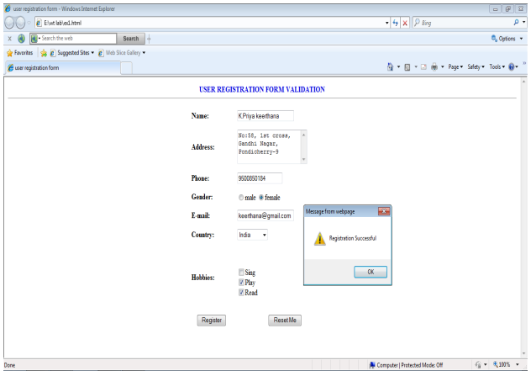
REG NO: 22TD0053 NAME: MOHAMED B SIRAJUDDEEN
YEAR/SEM/SEC: Y3/S6/B

USER REGISTRATION FORM VALIDATION USING JAVASCRIPT
SOURCE CODE
<html>
<head>
<title>Form Validation Example</title>
<script>
function ValidateContactForm()
{
var name = document.ContactForm.Name;
var email = document.ContactForm.Email;
var phone = document.ContactForm.Telephone;
var nocall = document.ContactForm.DoNotCall;
var what = document.ContactForm.Subject;
var comment = document.ContactForm.Comment;
if (name.value == "")
{
window.alert("Please enter your name.");
name.focus();
return false;
}
if (email.value == "")
{
window.alert("Please enter a valid e-mail address.");
email.focus();
return false;
}
if (email.value.indexOf("@", 0) < 0)
{
window.alert("Please enter a valid e-mail address.");
email.focus();
return false;
}
if (email.value.indexOf(".", 0) < 0)
{
window.alert("Please enter a valid e-mail address.");
email.focus();
return false;
}
if ((nocall.checked == false) && (phone.value == ""))
{
window.alert("Please enter your telephone number.");
phone.focus();
return false;
}
if (what.selectedIndex < 1)
{
alert("Please tell us how we can help you.");
what.focus();
return false;
}
if (comment.value == "")
{
window.alert("Please provide a detailed description or comment.");
comment.focus();
return false;
}
return true;
}
function EnableDisable(chkbx)
{
if(chkbx.checked == true)
{
document.ContactForm.Telephone.disabled = true;
}
else
{
document.ContactForm.Telephone.disabled = false;
}
}
</script>
</head>
<body>
<center><font color="blue" size="5"><h1>Validation Form</h1></font></center>
<hr>
<br>
<form method="post" action="mailto:paul@drsjspaulmcet.edu.in"
name="ContactForm" onsubmit="return ValidateContactForm();">
<center>
<table>
<tr><td>Name: </td>
<td><input type="text" size="65" name="Name"></td>
</tr>
<tr><td>E-mail Address: </td>
<td> <input type="text" size="65" name="Email"></td>
</tr><tr><td>Telephone: </td>
<td> <input type="text" size="65" name="Telephone"></td>
</tr>
</tr><tr><td colspan="2"> <input type="checkbox" name="DoNotCall"
onclick="EnableDisable(this);"> Please do not call me.</td>
</tr>
<tr><td>What can we help you with? </td>
<td> <select type="text" value="" name="Subject">
<option> </option>
<option>Customer Service</option>
<option>Question</option>
<option>Comment</option>
<option>Consultation</option>
<option>Other</option>
</select></td>
</tr>
<tr><td>Comments: </td>
<td><textarea cols="55" name="Comment"> </textarea></td>
</tr>
<tr><td><input type="submit" value="Send" name="submit"></td>
<td><input type="reset" value="Reset" name="reset"></td>
</tr>
</table>
</center>
</form>
</body>
</html>

OUTPUT
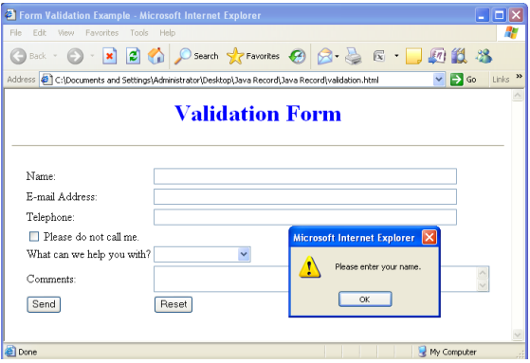
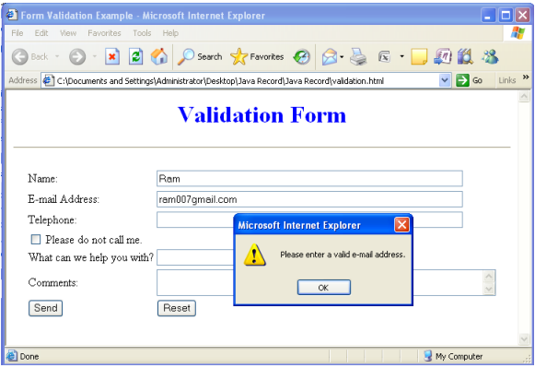
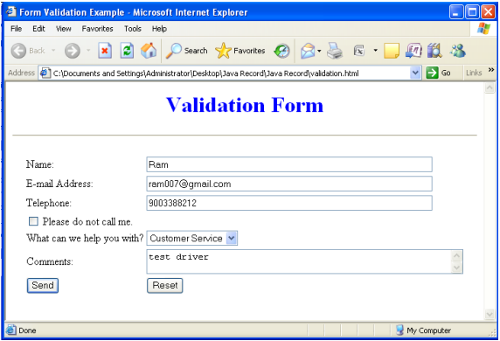
REG NO: 22TD0053 NAME: MOHAMED B SIRAJUDDEEN
YEAR/SEM/SEC: Y3/S6/B

USER REGISTRATION FORM VALIDATION USING VBSCRIPT

SOURCE CODE
<html>
<head>
<script language="vbscript">
function radiogroupvalid(radgroup)
dim radno
radiogroupvalid=false
for radno=0 to radgroup.length-1
if radgroup(radno).checked=true then
radiogroupvalid=true
end if
next
end function
function countryvalid(cgroup)
dim cno
countryvalid=false
for cno=0 to cgroup.length-1
if cgroup(cno).selected=true then
countryvalid=true
end if
next
end function
function checkboxvalid(checkgroup)
dim checkno
checkboxvalid=false
for checkno=0 to checkgroup.length-1
if checkgroup(checkno).checked=true then
checkboxvalid=true
end if
next
end function
sub cmduserinfo_OnClick()
if len(form.txtname.value)<2 or IsNumeric(form.txtname.value) then
msgbox("type a valid name")
form.txtname.focus
form.txtname.select
elseif len(form.txtage.value) ="" or Not IsNumeric(form.txtage.value) then
msgbox("type a valid age")
form.txtage.focus
form.txtage.select
elseif len(form.txtph.value) ="" or Not IsNumeric(form.txtph.value) then
msgbox("type a valid phone number")
form.txtph.focus
form.txtph.select
elseif not radiogroupvalid(form.gender)then
msgbox("enter the gender")
elseif (form.txtmail.value ="") then
msgbox("enter the valid email")
form.txtmail.focus
form.txtmail.select
elseif instr(form.txtmail.value,"@") =0 then
msgbox("type a valid email")
form.txtmail.focus
elseif not countryvalid(form.country)then
msgbox("select your country")
elseif not checkboxvalid(form.hob)then
msgbox("check your hobbies")
else
msgbox("Registration Successful!!!")
end if
end sub
</script>
</head>
<body>
<form name="form" method="post">
<center>
<center><strong> <font color="voilet">USER REGISTRATION FORM VALIDATION
using VBSCRIPT</font></strong></center>
<hr>
<table width="30%" cellspacing="35" cellpadding="0" border="0"
<tr>
<td>
<b>Name:</b><td><input type="text" name="txtname">
</tr>
<tr>
<td><b>Age:</b><td><input type="text" name="txtage">
</tr>
<tr>
<td><b>Phone:</b><td><input type="text" size="15" name="txtph">
</tr>
<tr><td><b>Gender:</b><td><input type=radio name=gender >Male
<input type=radio name=gender >Female
</tr>
<tr>
<td><b>E-mail:<td><input type="text" name="txtmail" >
</tr>
<tr>
<td><b>Country:<td><select name="country" size="3">
<option><option value=India> India
<option><option value= Pakistan>Pakistan
<option><option value= Australia>Australia
</select>
</tr>
<tr>
<td><b>Hobbies:</b>
<td><input type=checkbox name=hob value=read>read
<input type=checkbox name=hob value=sing>sing
<input type=checkbox name=hob value=play>play</tr>
<tr>
<td><center><input type="button" name="cmduserinfo" value="Register"></center>
<td><center><input type="reset" value="Reset Me"></center>
</tr>
</table>
</center>
</form>
</body>
</html>

OUTPUT
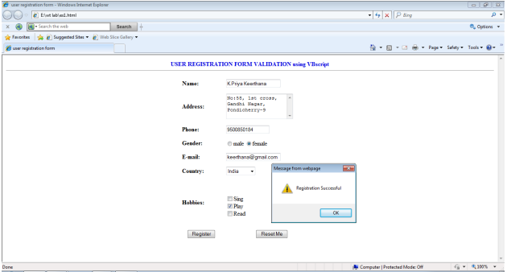
REG NO: 22TD0053 NAME: MOHAMED B SIRAJUDDEEN
YEAR/SEM/SEC: Y3/S6/B

EMPLOYEE PAYROLL USING VBSCRIPT

SOURCE CODE
<html>
<head>
<Script Language="VBScript">
<!--
Sub GiveFocus
Document.EmployeesPayroll.txtFirstName.Focus()
End Sub
Function GetFullName()
Dim FirstName, LastName
FirstName = Document.EmployeesPayroll.txtFirstName.Value
LastName = Document.EmployeesPayroll.txtLastName.Value
GetFullName = LastName & ", " & FirstName
End Function
Function CalculateWeeklySalary(HourlySalary, WeeklyHours, OverTimeHours)
dim OverTimeSalary
OverTimeSalary=OverTimeHours*1.5*HourlySalary
WeeklyHours=WeeklyHours-OverTimeHours
CalculateWeeklySalary = (HourlySalary * WeeklyHours)+OverTimeSalary
End Function
Sub ProcessPayroll()
Dim dMon, dTue, dWed, dThu, dFri, dSat, dSun, TotalHours,OverTimeHours
Dim HourlySalary, WeeklySalary
Dim FullName
dMon = CDbl(Document.EmployeesPayroll.txtMon.Value)
dTue = CDbl(Document.EmployeesPayroll.txtTue.Value)
dWed = CDbl(Document.EmployeesPayroll.txtWed.Value)
dThu = CDbl(Document.EmployeesPayroll.txtThu.Value)
dFri = CDbl(Document.EmployeesPayroll.txtFri.Value)
dSat = CDbl(Document.EmployeesPayroll.txtSat.Value)
dSun = CDbl(Document.EmployeesPayroll.txtSun.Value)
HourlySalary = Document.EmployeesPayroll.txtHourlySalary.Value
TotalHours = dMon + dTue + dWed + dThu + dFri + dSat + dSun
if(TotalHours>56)then
OverTimeHours=TotalHours-56
else
OverTimeHours=0
end if
WeeklySalary = CalculateWeeklySalary(HourlySalary, TotalHours,OverTimeHours)
FullName = GetFullName()
PayrollResults.txtFullName.Value = FullName
PayrollResults.txtWeeklyEarnings.Value = "$" & WeeklySalary
End Sub
-->
</Script>
<title>Employees Payroll</title>
</head>
<body OnLoad="GiveFocus()">
<h1>Employees Payroll</h1>
<form name="EmployeesPayroll" method="POST">
<table border="0" width="548">
<tr>
<td width="104">First Name:</td>
<td width="430"><input type="text" name="txtFirstName" size="20"></td>
</tr>
<tr>
<td width="104">LastName:</td>
<td width="430"><input type="text" name="txtLastName" size="20"></td>
</tr>
</table>
<table border="0" width="548">
<tr>
<td width="104">Hourly Salary</td>
<td width="428"><input type="text" name="txtHourlySalary" size="10" value="0.00"></td>
</tr>
</table>
<table border="0" width="563">
<tr>
<td width="124">Weekly Hours</td>
<td width="62" align="center">Mon</td>
<td width="62" align="center">Tue</td>
<td width="62" align="center">Wed</td>
<td width="62" align="center">Thu</td>
<td width="62" align="center">Fri</td>
<td width="62" align="center">Sat</td>
<td width="62" align="center">Sun</td>
</tr>
<tr>
<td width="124"></td>
<td width="62" align="center"><input type="text" name="txtMon" size="6"
value="0.00"></td>
<td width="62" align="center"><input type="text" name="txtTue" size="6"
value="0.00"></td>
<td width="62" align="center"><input type="text" name="txtWed" size="6"
value="0.00"></td>
<td width="62" align="center"><input type="text" name="txtThu" size="6"
value="0.00"></td>
<td width="62" align="center"><input type="text" name="txtFri" size="6"
value="0.00"></td>
<td width="62" align="center"><input type="text" name="txtSat" size="6"
value="0.00"></td>
<td width="62" align="center"><input type="text" name="txtSun" size="6"
value="0.00"></td>
</tr>
</table>
<table border="0" width="558">
<tr>
<td width="104"></td>
<td width="440">
<p><input type="button" value="Process" name="btnProcess"
OnClick="ProcessPayroll()">
&nbsp;&nbsp;
<input type="reset" value="Reset" name="B2">
</p>
</td>
</tr>
</table>
</form>
<hr>
<form name="PayrollResults">
<table border="0" width="546">
<tr>
<td width="113">Full Name:</td>
<td width="419"><input type="text" name="txtFullName" size="20"></td>
</tr>
</table>
<table border="0" width="545">
<tr>
<td width="112">Weekly Earnings:</td>
<td width="419"><input type="text" name="txtWeeklyEarnings" size="20"
value="$0.00"></td>
</tr>
</table>
</form>
</body>
</html>

OUTPUT
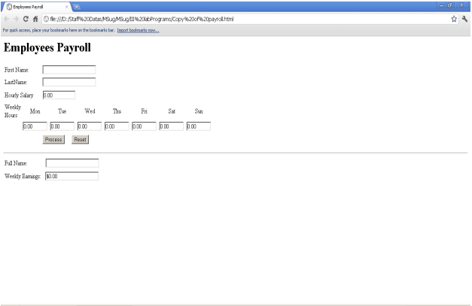
REG NO: 22TD0053 NAME: MOHAMED B SIRAJUDDEEN
YEAR/SEM/SEC: Y3/S6/B

APACHE TOMCAT SERVER

Step 1:
Installation of JDK:
Before beginning the process of installing Tomcat on your system, ensure first the
availability of JDK on your system program directory. Install it on your system if not already
installed (because any version of tomcat requires the Java 1.6 or higher versions) and then set the
class path (environment variable) of JDK. To set the JAVA_HOME Variable: you need to
specify the location of the java run time environment to support the Tomcat else Tomcat server
cannot run.
This variable contains the path of JDK installation directory.
set JAVA_HOME=C:\Program Files\Java\jdk1.6
Note: it should not contain the path up to bin folder. Here, we have taken the URL path according
to our installation convention.
For Windows OS, go through the following steps:
Start menu->Control Panel->System->Advanced tab->Environment Variables->New->
set the Variable name = JAVA_HOME and variable value = C:\Program Files\Java\jdk1.6
Now click on all the subsequent ok buttons one by one. It will set the JDK path.
Step 2:
For setting the class path variable for JDK, do like this:
Start menu->Control Panel->System->Advanced tab->Environment Variables->New->
Set PATH="C:\Program Files\Java\jdk1.6\bin"; %PATH%
OR
First, right click on the
My Computer->properties->advance->Environment Variables->path.
Now, set bin directory path of JDK in the path variable

Step 3:
The process of installing Tomcat 6.0 begins here from now. It takes various steps for
installing and configuring the Tomcat 6.0.
For Windows OS, Tomcat comes in two forms: .zip file and .exe file (the Windows
installer file). Here we are exploring the installation process by using the .exe file. First unpack
the zipped file and simply execute the '.exe' file. 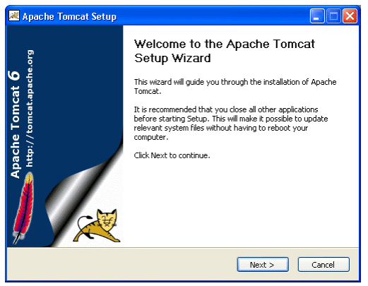
A Welcome screen shot appears that shows the beginning of installation process. Just click
on the 'Next' button to proceed the installation process.
Steps 4:
A screen of 'License Agreement' displays.
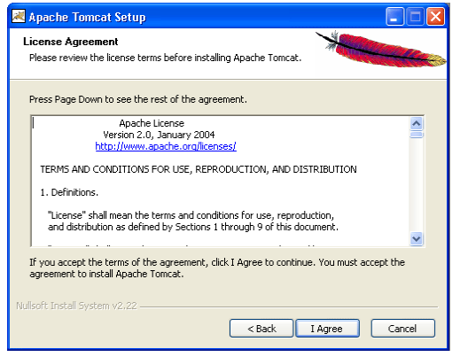
Click on the 'I Agree' button.
Step 5:
A screen shot appears asking for the 'installing location'
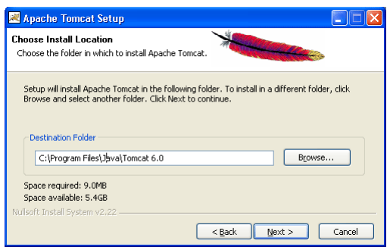
Choose the default components and click on the 'Next' button.
Step 6:
A screen shot of 'Configuration Options' displays on the screen. Choose the location for
the Tomcat files as per your convenience. You can also opt the default Location
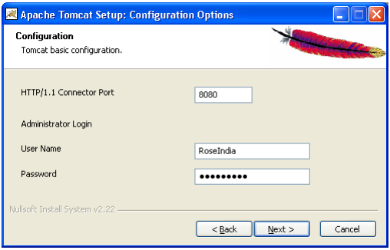
The port number will be your choice on which you want to run the tomcat server. The port
number 8080 is the default port value for tomcat server to proceed the HTTP requests. The user
can also change the 'port number' after completing the process of installation; for this, users have
to follow the following tips.
Go to the specified location as " Tomcat 6.0 \conf \server.xml ". Within the server.xml
file choose "Connector" tag and change the port number.
Now, click on the 'Next' button to further proceed the installation process.
Step 7:
A Window of Java Virtual Machine displays on the screen
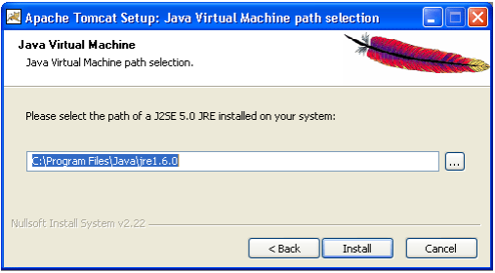
This window asks for the location of the installed Java Virtual Machine. Browse the
location of the JRE folder and click on the Install button. This will install the Apache tomcat at
the specified location.
Step 8:
A processing window of installing displays on the screen.
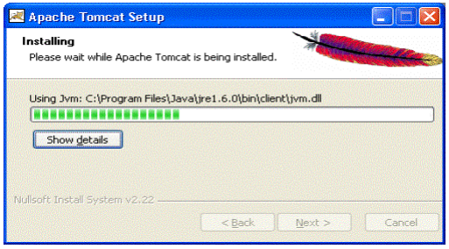
To get the information about installer click on the "Show details" button
Step 9:
A screen shot of 'Tomcat Completion' displays on the screen.
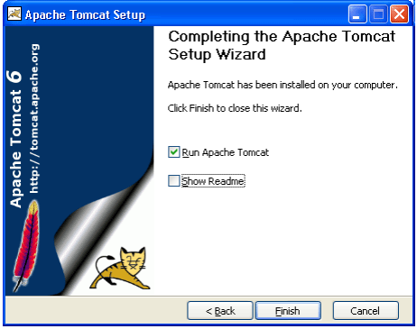
Click on the 'Finish' button.
Step 10:
A window of Apache Service Manager appears with displaying the running process.
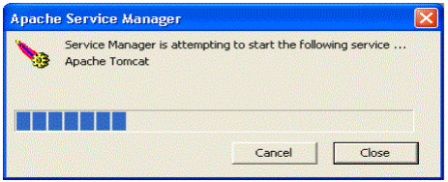
Let the running process goes on.
Step 11:
After completing the installation process, the Apache Tomcat Manager appears on the
toolbar panel like shown in the below picture.
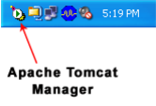
Configuring Tomcat Manager
To Configure the Tomcat Manager, there are two ways; either user can configure Tomcat
directly from the toolbar panel or can configure it from Control Panel Section.
i-) Configuring from toolbar Panel
To Configure Apache Tomcat web server from the toolbar panel, you have to press
'double click' on the appeared icon.
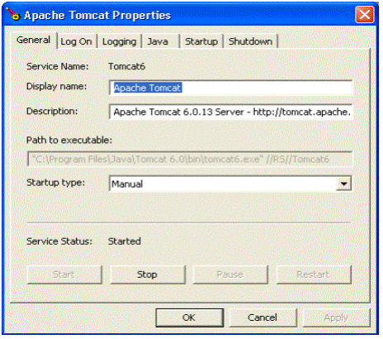
A configured window appears on the desktop. Now, just click on the Startup button. The
installation process will be completed.
ii-) Configuration from the Control Panel
To configure the Apache Tomcat Manager, Users will have to follow the following steps:
Click on the Startup button -- select Control Panel -- Administrator Tool -- Services -- select
Apache Tomcat.
The following screen displays on the monitor.
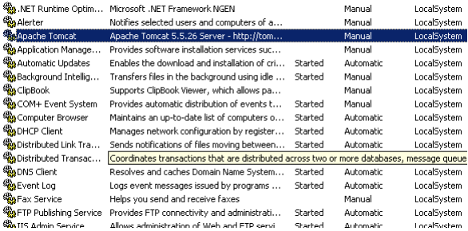
Double click on the Apache Tomcat. The window of Apache Tomcat Properties appears on the
screen.
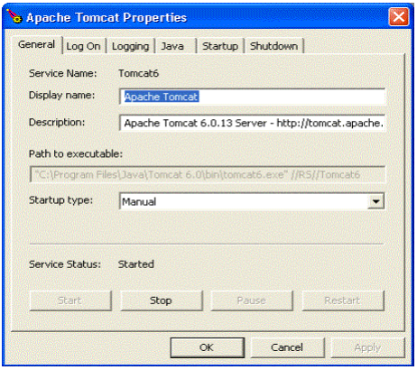
Now, Click on the start up button. The Apache Tomcat is now ready to function.
To operate it, follow the below steps of processing.
Start the Tomcat Server:
1.Start the tomcat server from the bin folder of Tomcat 6.0 directory by double clicking the
"tomcat6.exe" file.
OR create a shortcut of this .exe file at your desktop.
2. Now Open web browser and type URL http://localhost:8080 in the address bar to test the server
3. To Stop the Tomcat Server: Stop the server by pressing the "Ctrl + c" keys.
The screen of Apache Tomcat software looks like this:
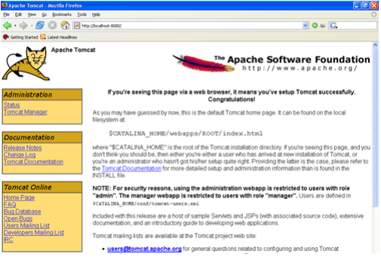

REG NO: 22TD0053 NAME: MOHAMED B SIRAJUDDEEN
YEAR/SEM/SEC: Y3/S6/B

IIS INSTALLATION

The following steps are needed to install IIS on Windows Xp,
1. Go to Control Panel, click Add or Remove Programs.
2. Select Add/Remove Windows Components.
3. Select Internet Information Services (IIS).
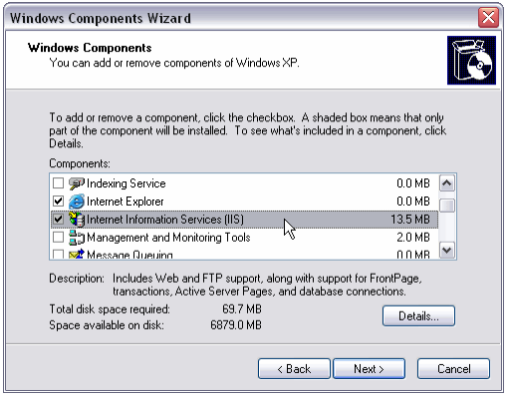
4. Click Details.
5. Uncheck the SMTP protocol.
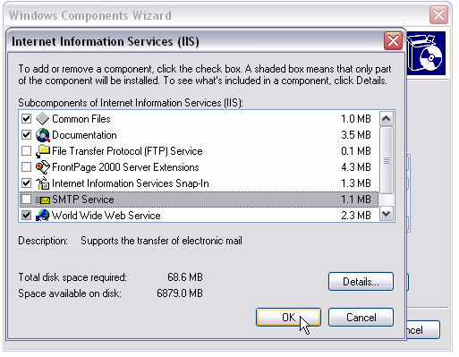
6. Click Ok then Next, and wait for the IIS installation to finish. We will need Windows XP Pro
CD, or the i386 source available on the computer or on a network location.
Creating the Virtual Directory in IIS
Next we need to create the “Calendar” Virtual Directory in IIS.
1. Open Administrative Tools, then double click Internet Information Services.
2. Expand the view so you can see Default Web Site.
3. Right click on it and choose New -> Virtual Directory.
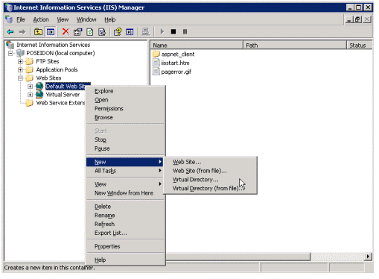
4. In the Virtual Directory wizard click Next.
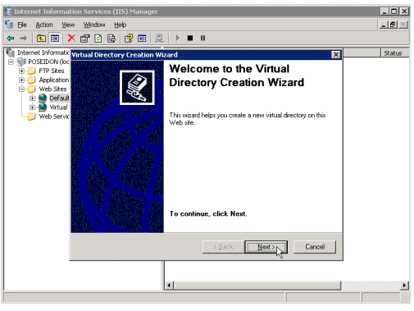
5. In the Alias box, type a descriptive name such as Calendar. We will use this name to access
the calendar virtual directory.
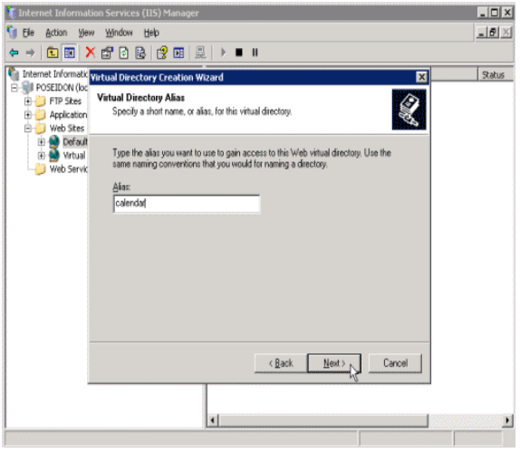
6. In the Path box enter the path to where you want to store the calendar files on the hard drive.
This needs to be a folder all users will have access to - I recommend creating a folder in the root
of the hard drive, such as D:\Calendar.
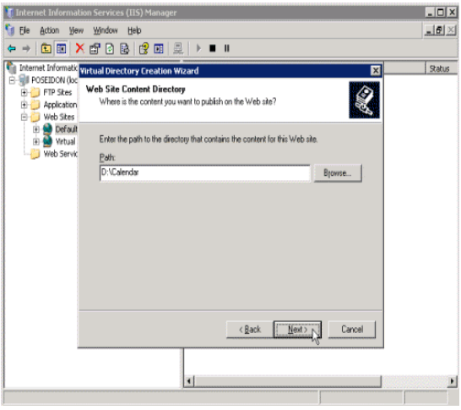
7. We need Read and Write permission on this virtual directory, so select the Write checkbox
along with the Read checkbox which is already selected.
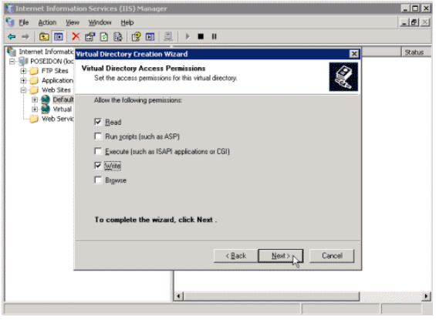
8. Click Finish.
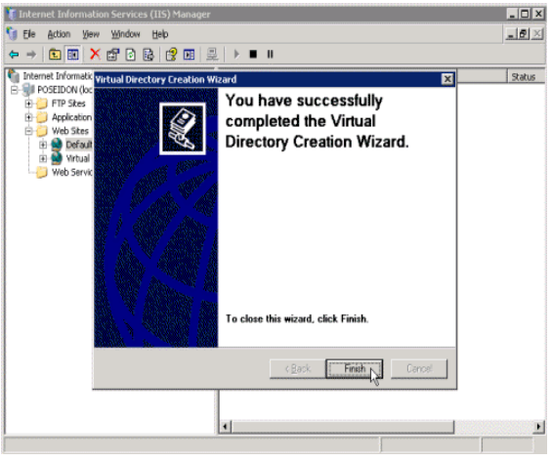

REG NO: 22TD0053 NAME: MOHAMED B SIRAJUDDEEN
YEAR/SEM/SEC: Y3/S6/B

ACTIVEX CONTROLS IN WEB DOCUMENTS

SOURCE CODE
<HTML>
<HEAD>
<TITLE> The Calendar Control </TITLE>
</HEAD>
<BODY BGCOLOR="#FFFFFF">
<P><OBJECT ID="Calendar1"
WIDTH=600
HEIGHT=380
CLASSID="CLSID:8E27C92B-1264-101C-8A2F-040224009C02"
ALIGN=LEFT
HSPACE=1>
</OBJECT>
<INPUT TYPE="BUTTON" NAME="PreviousDay" VALUE="< Day">
<BR>
<INPUT TYPE="BUTTON" NAME="PreviousMonth" VALUE="<< Month">
<BR>
<INPUT TYPE="BUTTON" NAME="PreviousYear" VALUE="<<| Year">
<BR>
<INPUT TYPE="BUTTON" NAME="NextYear" VALUE="Year |>>"</P>
<BR>
<INPUT TYPE="BUTTON" NAME="NextMonth" VALUE="Month >>">
<BR>
<INPUT TYPE="BUTTON" NAME="NextDay" VALUE="Day >">
</P>
<SCRIPT LANGUAGE="VBScript">
<!--
Calendar1.Year = 1997
Calendar1.Month = 1
Calendar1.Day = 1
Sub PreviousDay_OnClick
Calendar1.PreviousDay
End Sub
Sub NextDay_OnClick
Calendar1.NextDay
End Sub
Sub PreviousMonth_OnClick
Calendar1.PreviousMonth
End Sub
Sub NextMonth_OnClick
Calendar1.NextMonth
End Sub
Sub PreviousYear_OnClick
Calendar1.PreviousYear
End Sub
Sub NextYear_OnClick
Calendar1.NextYear
End Sub
-->
</SCRIPT>
</BODY>
</HTML>

OUTPUT
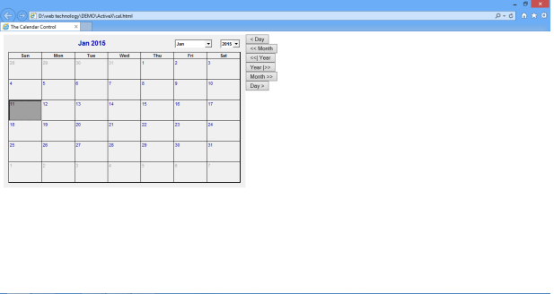
REG NO: 22TD0053 NAME: MOHAMED B SIRAJUDDEEN
YEAR/SEM/SEC: Y3/S6/B

DATABASE CONNECTION USING JSP

SOURCE CODE
Insert.html
<html>
<form method="post" action="http://localhost:8080/my project/insert.jsp">
<table>
<tr>
<td>Name:</td>
<td><input type="text" name="name"></td>
</tr>
<tr>
<td>Password:</td>
<td><input type="password" name="pwd"></td>
</tr>
<tr>
<td><input type="submit" value="Submit"></td>
</tr>
</table>
</form>
</html>

Insert.jsp
<%@page import="java.sql.*"%>
<%
String name=request.getParameter("name");
String pwd=request.getParameter("pwd");
Class.forName("sun.jdbc.odbc.JdbcOdbcDriver");
Connection con = DriverManager.getConnection("jdbc:odbc:student");
Statement st=con.createStatement();
int i=st.executeUpdate("insert into user (uname,pwd) values('"+name+"','"+pwd+"')");
out.println("Data is inserted successfully");
%>
Update.html
<html>
<head>
<title>Update</title>
</head>
<body>
<h2>UPDATION</h2>
<form method="post" action="http://localhost:8080/my project/update.jsp">
<br>
<br>
<table border = "2">
<tr align="left" valign="top">
<td>Name:</td>
<td><input type="text" name ="name"></td>
</tr>
<tr align="left" valign="top">
<td>Role:</td>
<td><input type="text" name ="role" /></td>
</tr>
<tr align="left" valign="top">
<td></td>
<td><input type="submit" value="submit"/></td>
</tr>
</table>
</form>
</body>
</html>
Update.jsp
<html><body>
<%@page language ="java" import="java.sql.*"%>
<%
String name= request.getParameter("name");
String role= request.getParameter("role");
Class.forName("sun.jdbc.odbc.JdbcOdbcDriver");
Connection con = DriverManager.getConnection("jdbc:odbc:student");
Statement st = con.createStatement();
int i =st.executeUpdate("update user set role= '"+role+"' where uname='"+name+"'");
out.println("Updated successfully");
%>
</body>
</html>

OUTPUT
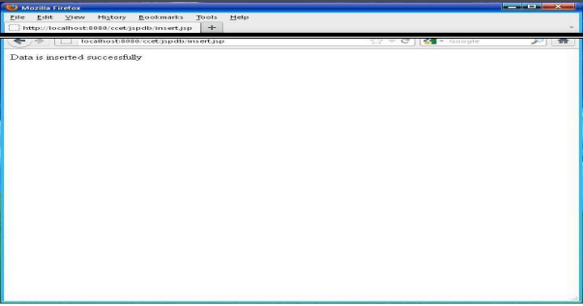
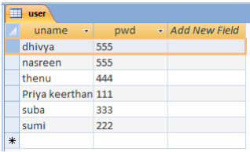
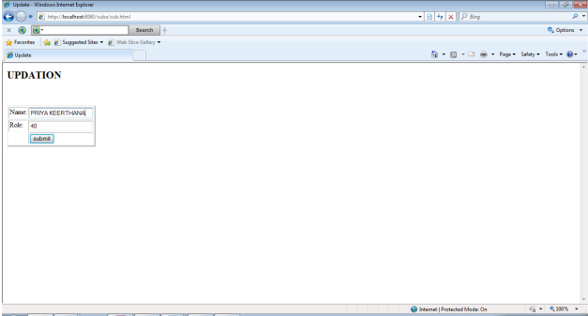
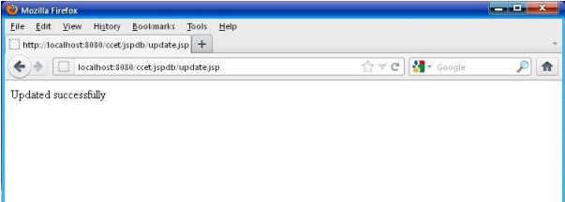
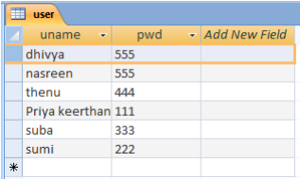
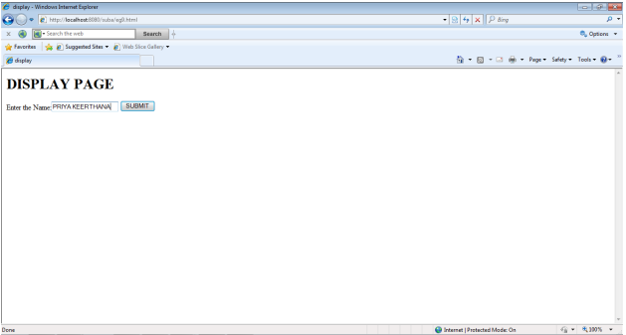
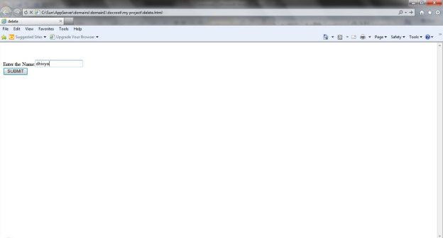
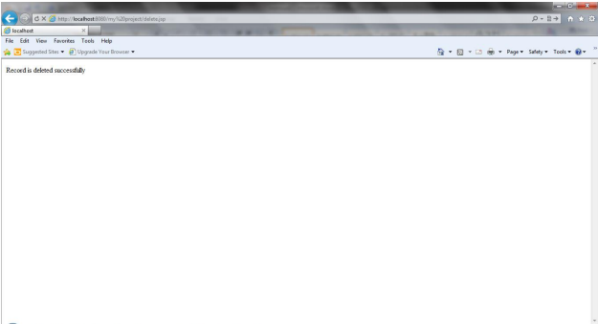
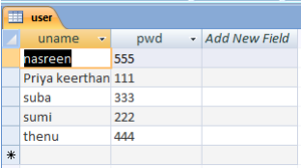
REG NO: 22TD0053 NAME: MOHAMED B SIRAJUDDEEN
YEAR/SEM/SEC: Y3/S6/B

APPLICATION OBJECT
SOURCE CODE
Applicationobject.jsp
<%@ page language="java" %>
<%@ page import="java.sql.*" %>
<%
String name="anbu";
getServletContext().setAttribute("value1","welcome");
String getvalue1=(String)getServletContext().getAttribute("value1");
application.setAttribute("value2",name);
String getvalue2=(String)application.getAttribute("value2");
%>
<html>
<head>
<title>Application object in JSP</title>
</head>
<body>
<%=getvalue1%>
<%=getvalue2%>
</body>
</html>

OUTPUT
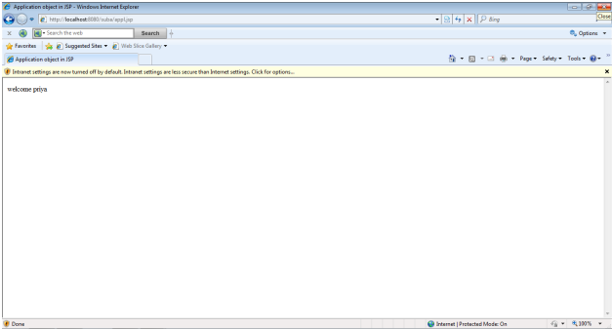
REG NO: 22TD0053 NAME: MOHAMED B SIRAJUDDEEN
YEAR/SEM/SEC: Y3/S6/B

SESSION OBJECT

SOURCE CODE
Session.jsp
<%@ page language="java" import="java.util.*"%>
<html>
<body>
<form name="form" method="get" action="sessionsetretrieve.jsp">
<table width="25%" border="0" cellspacing="10" cellpadding="0">
<tr>
<td>Name:
<td><input type="text" name="name">
</tr> <tr>
<td>Id:
<td><input type="text" name="id">
</tr> <tr>
<td>Mark1:
<td><input type="text" name="m1">
</tr> <tr>
<td>Mark2:
<td><input type="text" name="m2">
</tr> <tr>
<td>Mark3:
<td><input type="text" name="m3">
</tr>
<tr><td><input type="submit" name="submit" value="submit">
</tr>
</table>
</form>
</body>
</html>
SessionSetRetrieve.jsp
<%@ page language="java" import="java.util.*"%>
<% String sessionSet1=request.getParameter("name");
session.setAttribute("MySession1",sessionSet1);
String sessionSet2=request.getParameter("id");
session.setAttribute("MySession2",sessionSet2);
String sessionSet3=request.getParameter("m1");
session.setAttribute("MySession3",sessionSet3);
String sessionSet4=request.getParameter("m2");
session.setAttribute("MySession4",sessionSet4);
String sessionSet5=request.getParameter("m3");
session.setAttribute("MySession5",sessionSet5); %>
<html> <head>
<title>Session Set Retrieve</title>
</head> <body>
NAME:<%=(String)session.getAttribute("MySession1")%><br>
ID:<%=(String)session.getAttribute("MySession2")%><br>
MARK1:<%=(String)session.getAttribute("MySession3")%><br>
MARK2:<%=(String)session.getAttribute("MySession4")%><br>
MARK3:<%=(String)session.getAttribute("MySession5")%><br>
</body>
</html>

OUTPUT
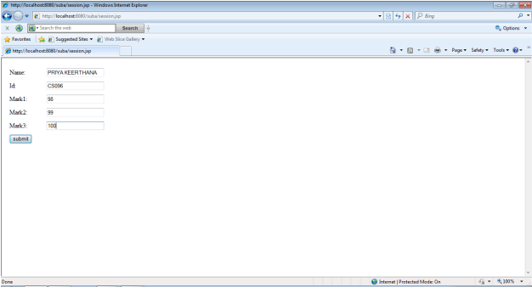
REG NO: 22TD0053 NAME: MOHAMED B SIRAJUDDEEN
YEAR/SEM/SEC: Y3/S6/B

TRACKING USER SESSION

SOURCE CODE
trackingusersession.jsp
<%@ page import="java.util.*" %>
<html>
<head>
<title>tracking session</title>
</head>
<body>
<center>
<table style="background color=lightyellow" cellspacing="5" border="1">
<% Integer counter=(Integer)session.getAttribute("counter");
if(counter==null)
{
counter=1;
}
else
{
counter=counter+1;
}
session.setAttribute("counter",counter);
%>
<tr>
<th>Session Id</th>
<td><%=session.getId()%>
</tr><tr>
<th>Session Creation time</th>
<td><%= new Date(session.getCreationTime())%>
</tr>
<tr>
<th>Last Accessed Time</th>
<td><%=new Date(session.getLastAccessedTime())%>
</tr>
<tr>
<th>Visited</th>
<td><%=(Integer)session.getAttribute("counter")%> times
</tr>
</table>
</center>
</body>
</html>

OUTPUT
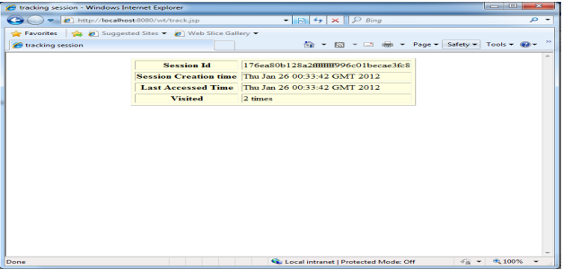
REG NO: 22TD0053 NAME: MOHAMED B SIRAJUDDEEN
YEAR/SEM/SEC: Y3/S6/B

FILE SYSTEM MANAGEMENT

SOURCE CODE
Singlefile.jsp
<%@ page language="java" %>
<HTml>
<HEAD><TITLE>Display file upload form to the user</TITLE></HEAD>
<% // for uploading the file we used Encrypt type of multipart/
form-data and input of file type to browse and submit the file %>
<BODY>
<FORM ENCTYPE="multipart/form-data" ACTION="single_upload_page.jsp"
METHOD=POST>
<br><br><br>
<center>
<table border="2" >
<tr><center><td colspan="2"><p align="center"><B>PROGRAM FOR UPLOADING THE
FILE</B><center></td></tr>
<tr><td><b>Choose the file To Upload:</b>
</td>
<td><INPUT NAME="F1" TYPE="file"></td></tr>
<tr><td colspan="2">
<p align="right"><INPUT TYPE="submit" VALUE="Send File" ></p></td></tr>
<table>
</center>
</FORM>
</BODY>
</HTML>

single_upload_page.jsp
<%@ page import="java.io.*" %>
<%
String contentType = request.getContentType();
if ((contentType != null) && (contentType.indexOf("multipart/form-data") >= 0))
{
DataInputStream in = new DataInputStream(request.getInputStream());
int formDataLength = request.getContentLength();
byte dataBytes[] = new byte[formDataLength];
int byteRead = 0;
int totalBytesRead = 0;
while (totalBytesRead < formDataLength)
{
byteRead = in.read(dataBytes, totalBytesRead, formDataLength);
totalBytesRead += byteRead;
}
String file = new String(dataBytes);
String saveFile = file.substring(file.indexOf("filename=\"") + 10);
saveFile = saveFile.substring(0, saveFile.indexOf("\n"));
saveFile = saveFile.substring(saveFile.lastIndexOf("\\") + 1,saveFile.indexOf("\""));
int lastIndex = contentType.lastIndexOf("=");
String boundary = contentType.substring(lastIndex + 1,contentType.length());
int pos;
pos = file.indexOf("filename=\"");
pos = file.indexOf("\n", pos) + 1;
pos = file.indexOf("\n", pos) + 1;
int boundaryLocation = file.indexOf(boundary, pos) - 4;
int startPos = ((file.substring(0, pos)).getBytes()).length;
int endPos = ((file.substring(0, boundaryLocation)).getBytes()).length;
FileOutputStream fileOut = new FileOutputStream(saveFile);
fileOut.write(dataBytes, startPos, (endPos - startPos));
fileOut.flush();
fileOut.close();
%><Br>
<table border="2"><tr><td><b>You have successfully upload the file by the name of:</b>
<% out.println(saveFile); %></td></tr></table> <%
}
%>

OUTPUT
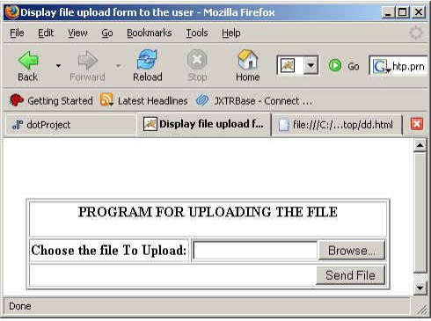
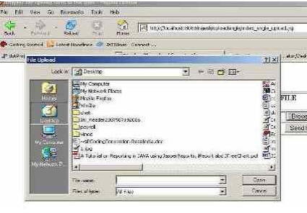
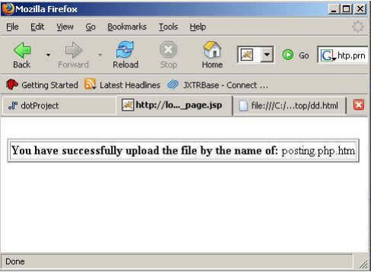
REG NO: 22TD0053 NAME: MOHAMED B SIRAJUDDEEN
YEAR/SEM/SEC: Y3/S6/B

GUEST BOOK USING ASP

SOURCE CODE
Guestbook form.html
<html>
<head>
<title>Guestbook Form</title>
</head>
<body bgcolor="white" text="black">
<form name="form" method="post" action="add_to_guestbook.asp">
Name: <input type="text" name="name" maxlength="20">
<br>
Comments: <input type="text" name="comments" maxlength="60">
<input type="submit" name="Submit" value="Submit">
</form>
</body>
</html>

_to_guestbook.asp
<%
Dim adoCon
Dim rsAddComments
Dim strSQL
Set adoCon = Server.CreateObject("ADODB.Connection")
adoCon.Open "DRIVER={Microsoft Access Driver (*.mdb)}; DBQ=" &
Server.MapPath("guestbook.mdb")
Set rsAddComments = Server.CreateObject("ADODB.Recordset")
strSQL = "SELECT tblComments.Name, tblComments.Comments FROM tblComments;"
rsAddComments.CursorType = 2
rsAddComments.LockType = 3
rsAddComments.Open strSQL, adoCon
rsAddComments.AddNew
rsAddComments.Fields("Name") = Request.Form("name")
rsAddComments.Fields("Comments") = Request.Form("comments")
rsAddComments.Update
rsAddComments.Close
Set rsAddComments = Nothing
Set adoCon = Nothing
Response.Redirect "guestbook.asp"
%>

Guestbook.asp
<html>
<head>
<title>Guestbook</title>
</head>
<body bgcolor="white" text="black">
<%
Dim adoCon
Dim rsGuestbook
Dim strSQL
Set adoCon = Server.CreateObject("ADODB.Connection")
adoCon.Open "DRIVER={Microsoft Access Driver (*.mdb)}; DBQ=" &
Server.MapPath("guestbook.mdb")
Set rsGuestbook = Server.CreateObject("ADODB.Recordset")
strSQL = "SELECT tblComments.Name, tblComments.Comments FROM tblComments;"
rsGuestbook.Open strSQL, adoCon
Do While not rsGuestbook.EOF
Response.Write ("<br>")
Response.Write (rsGuestbook("Name"))
Response.Write ("<br>")
Response.Write (rsGuestbook("Comments"))
Response.Write ("<br>")
rsGuestbook.MoveNext
Loop
rsGuestbook.Close
Set rsGuestbook = Nothing
Set adoCon = Nothing
%>
</body>
</html>

OUTPUT
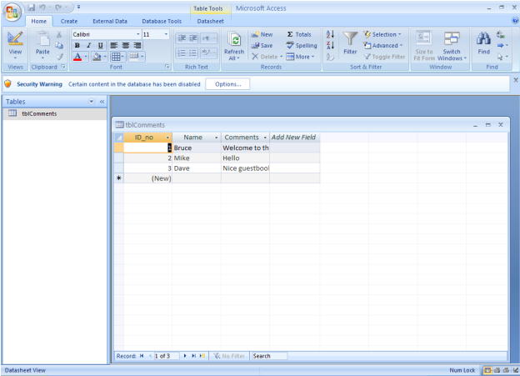
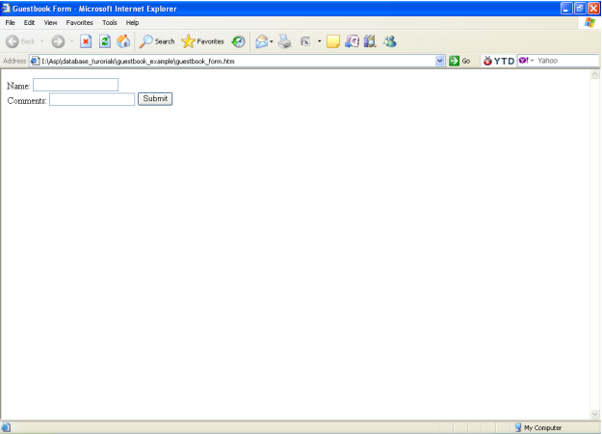
REG NO: 22TD0053 NAME: MOHAMED B SIRAJUDDEEN
YEAR/SEM/SEC: Y3/S6/B

JAVA SERVLET

SOURCE CODE
NewServlet.java
import java.io.*;
import java.net.*;
import javax.servlet.*;
import javax.servlet.http.*;
public class NewServlet extends HttpServlet {
public void init(ServletConfig config) throws ServletException {
super.init(config);
}
public void destroy() {
}
public String display(int mark)
{
if(mark>90 && mark<=100)
{
return "S";
}
else if(mark>80 && mark<=90)
{
return("A");
}
else if(mark>70 && mark<=80)
{
return("B");
}
else if(mark>60 && mark<=70)
{
return("C");
}
else if(mark>55 && mark<=60)
{
return("D");
}
else if(mark>=50 && mark<55)
{
return("E");
}
else
{
return("Re Appear");
}
}
protected void processRequest(HttpServletRequest request, HttpServletResponse response)
throws ServletException, IOException {
response.setContentType("text/html");
PrintWriter out = response.getWriter();
try {
String name, reg;
int mark,s1,s2,s3,s4,s5,s6;
name = request.getParameter("name");
reg = request.getParameter("reg");
s1 = Integer.parseInt(request.getParameter("sub1"));
s2 = Integer.parseInt(request.getParameter("sub2"));
s3 = Integer.parseInt(request.getParameter("sub3"));
s4 = Integer.parseInt(request.getParameter("sub4"));
s5 = Integer.parseInt(request.getParameter("sub5"));
s6 = Integer.parseInt(request.getParameter("sub6"));
response.setContentType("text/html");
out.println("<html>");
out.println("<head>");
out.println("<title>Mark Report Servlet<title>");
out.println("</head>");
out.println("<body>");
out.println("<center><p><h2><b>Name :" + name + "</p>");
out.println("<p><b>Reg No :" + reg + "</p>");
out.println("<p><b>Your Mark Details</p><br><br></center>");
out.println("<center><table border=2 cellpadding=5 cellspacing=5>");
out.println("<tr><th>Subjects</th><th>Mark</th><th>Grade</th></tr>");
out.println("<tr><th>Sub1</th><td>"+s1 + "</td><td>" + display(s1) + "</td></tr>");
out.println("<tr><th>Sub2</th><td>"+s2 + "</td><td>" + display(s2) + "</td></tr>");
out.println("<tr><th>Sub3</th><td>"+s3 + "</td><td>" + display(s3) + "</td></tr>");
out.println("<tr><th>Sub4</th><td>"+s4 + "</td><td>" + display(s4) + "</td></tr>");
out.println("<tr><th>Sub5</th><td>"+s5 + "</td><td>" + display(s5) + "</td></tr>");
out.println("<tr><th>Sub6</th><td>"+s6 + "</td><td>" + display(s6) + "</td></tr></table>");
out.println("</body>");
out.println("</html>");
} finally {
out.close();
}
}
protected void doGet(HttpServletRequest request, HttpServletResponse response)
throws ServletException, IOException {
processRequest(request, response);
}
protected void doPost(HttpServletRequest request, HttpServletResponse response)
throws ServletException, IOException {
processRequest(request, response);
}
public String getServletInfo() {
return "Short description";
}
}

Index.html
<html>
<head><title>HTML Forms and Servlet</title></head>
<body>
<h1>Enter your Details</h1>
<form action = "http://localhost:8084/WebApplication4/NewServlet">
<table>
<tr>
<td>Name
<td><input type="text" name="name"><br><br>
</tr>
<tr>
<td>Reg No
<td><input type="text" name="reg"><br><br>
</tr>
<tr>
<td>Sub1 Mark
<td><input type="text" name="sub1"><br><br>
</tr>
<tr>
<td>Sub2 Mark
<td><input type="text" name="sub2"><br><br>
</tr>
<tr>
<td>Sub3 Mark
<td><input type="text" name="sub3"><br><br>
</tr>
<tr>
<td>Sub4 Mark
<td><input type="text" name="sub4"><br><br>
</tr>
<tr>
<td>Sub5 Mark
<td><input type="text" name="sub5"><br><br>
</tr>
<tr>
<td>Sub6 Mark
<td><input type="text" name="sub6"><br><br>
</tr>
</table>
<input type="submit">
</form>
</body>
</html>
OUTPUT
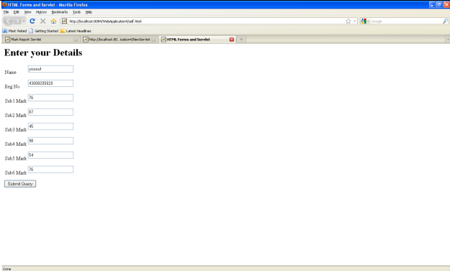
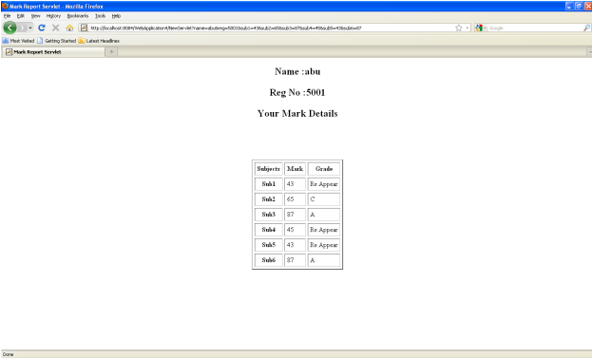
REG NO: 22TD0053 NAME: MOHAMED B SIRAJUDDEEN
YEAR/SEM/SEC: Y3/S6/B

CONTACT FORM USING PHP

SOURCE CODE
Form.html
<html>
<head>
<title>Program</title>
</head>
<body>
<FORM ACTION="Form.php" METHOD="POST">
Name: <INPUT TYPE=”text” NAME="name" > <BR>
Address 1:<INPUT TYPE=”text” NAME="add1" ><BR>
Address 2:<INPUT TYPE=”text” NAME="add2" ><BR>
E-mail:<INPUT TYPE=”text” NAME="email" ><BR>
<INPUT TYPE=SubmitQuery>
</FORM>
</body>
</html>

Form.php
<html>
<body>
<?php
$self = $_SERVER['PHP_SELF'];
$dbh = mysql_connect(“localhost”,”root”, “”) ordie(mysql_error());
mysql_select_db(“sug”) or die(mysql_error());
if(isset($_POST['name']))
{
$nme = $_POST['name'];
$ad1 = $_POST['add1'];
$ad2 = $_POST['add2'];
$eml = $_POST['email'];
if($nme != "" && $ad1 != "")
{
$query = "INSERT INTO contact VALUES('$nme', '$ad1', '$ad2', '$eml')";
$result = mysql_query($query) or die(mysql_error());
}
Else
echo "one of the field is empty";
}
mysql_close($dbh);
?>
<FORM ACTION="<?=$self?>" METHOD="POST">
<P>
Name: <INPUT TYPE=text NAME="name" value=""> <BR>
Address 1:<INPUT TYPE=text NAME="add1" value=""><BR>
Address 2:<INPUT TYPE=text NAME="add2" value=""><BR>
email:<INPUT TYPE=text NAME="email" value=""><BR>
<INPUT TYPE=submit>
</FORM>
</body>
</html>

Display.html
<html>
<head>
<title>Display</title>
</head>
<body>
<form action="Display.php" method="post">Enter Name of the person <input type="text" name="name">
<input type=submit>
</form>
</body>
</html>

Display.php
<head>
<title>Search Result </title>
</head>
<body>
<h3>Search Result</h3>
<hr>
<?php
$link=mysql_connect("localhost","root","");
mysql_select_db("sug");
$n=$_POST["name"];
print "Entered Name is $n \n";
$var=mysql_query("SELECT * FROM contact WHERE name like '%$n%'");
echo"<table border size=1>";
echo"<tr><th>Name</th>
<th>Address 1</th>
<th>Address 2</th>
<th>E-mail</th></tr>";
while ($arr=mysql_fetch_row($var))
{
echo "<tr><td>$arr[0]</td>
<td>$arr[1]</td>
<td>$arr[2]</td>
<td>$arr[3]</td> </tr>";
}
echo"</table>";
mysql_free_result($var);
mysql_close($link);
?>
<hr>
<form action="Display.html">
<input type="submit" value="Back">
</form>
</body>
</html>

OUTPUT
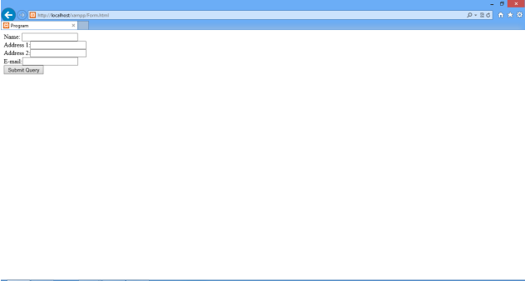
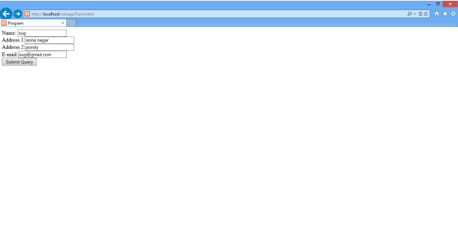
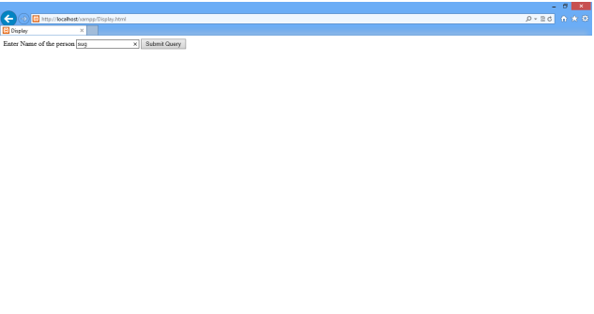
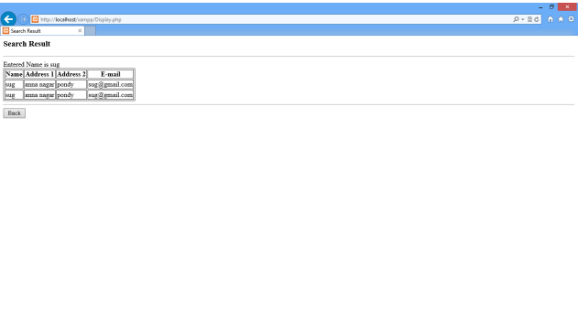
REG NO: 22TD0053 NAME: MOHAMED B SIRAJUDDEEN
YEAR/SEM/SEC: Y3/S6/B

SESSION USING PHP

SOURCE CODE
Session.php
<?php
session_start();session_register("count");
if (!isset($_SESSION))
{
$_SESSION["count"] = 0;
echo "<p>Counter initialized</p>\n";
}
else
{
$_SESSION["count"]++;
}echo "<p>The counter is now <b>$_SESSION[count]</b></p>"."
<p>reload this page to increment</p>";
?>

OUTPUT
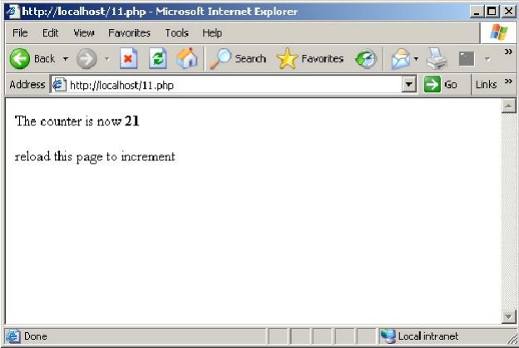
REG NO: 22TD0053 NAME: MOHAMED B SIRAJUDDEEN
YEAR/SEM/SEC: Y3/S6/B

AJAX

SOURCE CODE
Register.html
<html>
<head>
<title>Ajax Registration Program</title>
<script language="javascript">
function postRequest(strURL)
{
var xmlHttp;
if(window.XMLHttpRequest)
{
var xmlHttp=new XMLHttpRequest();
}
else if(window.ActiveXObject)
{
var xmlHttp=new ActiveXObject("Microsof.XMLHTTP");
}
xmlHttp.open('POST', strURL, true);
xmlHttp.setRequestHeader('Content-Type', 'application/x-www-form-urlencoded');
xmlHttp.onreadystatechange=function()
{
if(xmlHttp.readyState==4)
{
updatepage(xmlHttp.responseText);
}
}
xmlHttp.send(strURL);
}
function updatepage(str)
{
if(str=="no")
{
alert("Invalid Id/Password! Please fill Current Id/Password");
}
else
{
alert("Welcome for Register!");
}
}
function call_register()
{
var login_id=document.reg.uid.value;
var password=document.reg.passwd.value;
var url="Register.php?loginid="+login_id+"&password="+password+"";
postRequest(url);
}
</script>
</head>
<body>
<center>
<form name="reg">
<table border="1" width="30%">
<tr>
<td align="center" colspan="2"><font face="Monotype" size="5">Registration</font></td>
</tr>
<tr>
<td>Login Id:</td><td><input type="text" name="uid" size"20"></td>
</tr>
<tr>
<td>Password:</td><td><input type="password" name="passwd" size"20"></td>
</tr>
<tr>
<td align="center" colspan="2"><input type="submit" value="Register" OnClick="return
call_register()"
style="background-color:#FFE9D2; color:#0000FF; border-color:#99CC33"></td>
</tr>
</table>
</form>
</body>
</html>
Register.php
<?
$loginid=$_GET["loginid"];
$password=$_GET["password"];
if($password=="m"||$loginid=="m"||($loginid=="m"&&$password=="m")){
echo "no";
}
else{
echo "yes";
}
?>
OUTPUT
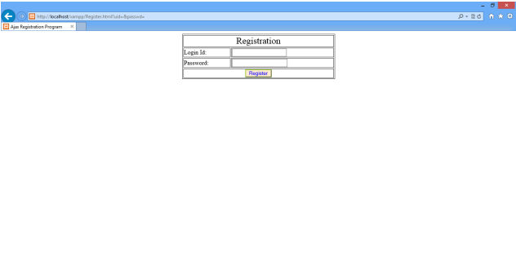

REG NO: 22TD0053 NAME: MOHAMED B SIRAJUDDEEN
YEAR/SEM/SEC: Y3/S6/B

XML

SOURCE CODE
Simplexml.xml
<?xml version="1.0" encoding="UTF-8"?>
<?xml-stylesheet type="text/xsl" href="student.xsl"?>
<student>
<Person_Info>
<Name>Barath</Name>
<Address>Chennai</Address>
<class>Second</class>
<Subject>Mathematics</Subject>
<Marks>100</Marks>
</Person_Info>
<Person_Info>
<Name>Ananth</Name>
<Address>Pune</Address>
<class>Fifth</class>
<Subject>English</Subject>
<Marks>80</Marks>
</Person_Info> <Person_Info>
<Name>Babu</Name>
<Address>Dhaka</Address>
<class>Tenth</class>
<Subject>English</Subject>
<Marks>90</Marks>
</Person_Info>
</student>
Student.xsl
<?xml version="1.0" encoding="ISO-8859-1"?>
<xsl:stylesheet version="1.0" xmlns:xsl="http://www.w3.org/1999/XSL/Transform">
<xsl:template match="/">
<html>
<body>
<h2>Student Database</h2>
<table border="5" cellspacing="10" cellpadding="10">
<tr bgcolor="gray">
<th>Name</th>
<th>Address</th>
<th>class</th>
<th>Subject</th>
<th>Marks</th> </tr>
<xsl:for-each select= "student/Person_Info">
<tr bgcolor="pink">
<td><xsl:value-of select="Name"/></td>
<td><xsl:value-of select="Address"/></td>
<td><xsl:value-of select="class"/></td>
<td><xsl:value-of select="Subject"/></td>
<td><xsl:value-of select="Marks"/></td> </tr>
</xsl:for-each>
</table> </body> </html>
</xsl:template>
</xsl:stylesheet>
OUTPUT
